EVENT DESCRIPTION SHEET
(To be filled in and uploaded as deliverable in the Portal Grant Management System, at the due date foreseen in the system.
Please provide one sheet per event (one event = one workpackage = one lump sum).)
PROJECT
Project name and acronym: |  | YO-WO: Young Workforce “ Youth and Gender equality for Europe's Welfare
Participant: |  | Youth center Velenje, Slovenia
PIC number: |  | 947286966
EVENT DESCRIPTION
Event number: | 8
Event name | La Pobla Llarga Institutional Conference and final conclusions
Type: | - Study visits to showcase the best experiences of the labour knowledge of the young participants involved with the project.  - Presentation of the results and best practices gathered during the development of every event of the project to institutional representatives at local, regional, national and international levels.
In situ/online: | In situ
Location: | Cyprus
Date(s): | 27-28/09/2024
Website(s) (if any): | https://tranquil-bienenstitch-592df3.netlify.app/project  https://www.lapoblallarga.es/va/pagina/projecte-yo-wo  https://www.lapoblallarga.es/va/noticia-pagina/projectes-europeus  www.bulgarian-youth.eu https://cardet.org/projects/yowo-young-workforce-youth-and-gender-equality-for-europe-s-welfare/ https://cardet.org/project-news/conclusion-of-yowo-project/  https://www.mc-velenje.si/evropski-projekt https://eidpfoundation.org/Projects/ https://www.ujszilvas.hu/ujszilvas/ https://autokreacja.org/blog/2024/11/14/yo-wo-young-workforce-youth-and-gender-equality-for-europes-welfare-summary/ https://ajmonnet.eu/es/yo-wo/
Participants
Female: | 20
Male: | 30
Non-binary: | 0
From country 1 Cyprus: | 21
From country 2 [Polska]: | 3
From country 3 [The Netherlands]: | 2
From country 4 [Spain] | 4
From country 5 [France] | 2
From country 6 [Slovenia] | 3
From country 7 [Hungary] | 2
From country [Bulgaria] | 3
Total number of participants: | 50 |  | From total number of countries: | 8
Description
Provide a short description of the event and its activities.

YOWO – CYPRUS
8th meeting
Ayia Napa, 27-28/09/2024 (26+29 travel days)
WP8: La Pobla Llarga Institutional Conference and final conclusions
PARTNER ORGANIZATIONS:
- Youth Center Velenje, Culture and Education (Slovenia)
- Municipality of La Pobla Llarga (Spain)
- Local Government of Town Újszilvás (Hungary)
- Fundacja Autokreacja (Poland)
- European Institute for Diplomacy and Policy (Netherlands)
- Jean Monnet (France)
- Bulgarian Youth Association (Bolgaria)
- CARDET (Cyprus)
OBJECTIVES:
- Communicate to a broad public and institutional representatives at local, regional, national and international levels all of the best practices which were gathered during the development of every event of the project
- Multiplier event and final conference to spread project results
- Conclusion of the project and launching of the sustainability phase
Description:
WP8:
1. Study Visits Showcasing the Best Practices in Labour Knowledge of Young Participants
Throughout the project, study visits were organized to highlight the labor-related knowledge and skills acquired by the young participants. These visits provided an opportunity for participants to share their most valuable experiences and learning outcomes with others. The showcased experiences focused on key achievements in vocational and professional development, including practical work experience, engagement in workplace environments, and innovative labor practices. These visits successfully facilitated peer learning and exchange among different groups, demonstrating the positive impact young people could have in the labor market.

2. Presentation of Project Results and Best Practices to Institutional Representatives
Following each event, formal presentations were held to share the results and best practices gathered during the project's development. These presentations were delivered to institutional representatives at local, regional, national, and international levels, ensuring wide dissemination. The results included data on the project’s effectiveness, participant success stories, and innovative practices that could be replicated in other contexts. These presentations engaged policy-makers and institutions, providing valuable insights that could influence future initiatives aimed at supporting youth employment and the development of labor knowledge.
Main activities:
-Study visit at CYherbia, botanical garden in Avgorou.
-Study visit at Thalassa museum in Ayia Napa
-Study visit at Octo microbrewery in Sotira
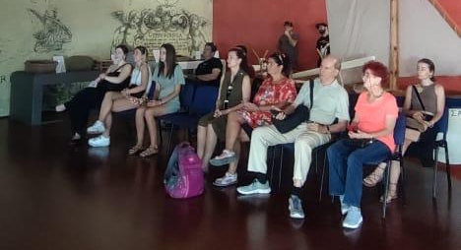
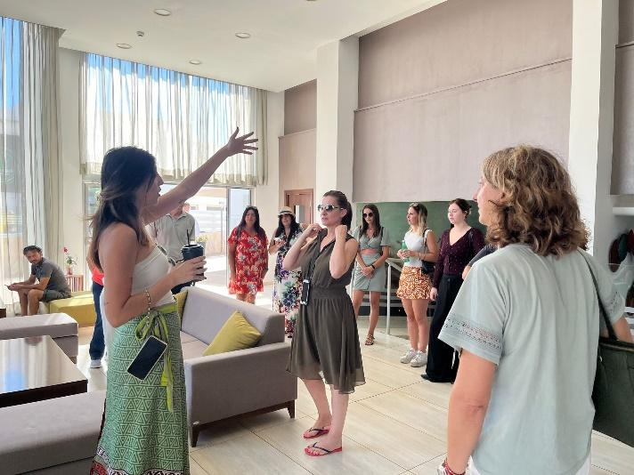

I) DESCRIPTION OF THE ACTIVITIES TAKEN PLACE
26.09.2024
Upon arriving in Ayia Napa, participants were warmly welcomed with a special dinner, marking the official start of the event. The welcome dinner provided an opportunity for everyone to gather in a relaxed setting, meet fellow participants, and begin building connections. During the evening, the organizers delivered a brief welcome speech, expressing excitement for the days ahead and outlining the goals of the project. The first words set a positive and collaborative tone, encouraging participants to engage fully in the upcoming activities. The dinner created a warm and friendly atmosphere, serving as the perfect introduction to the event.
27.09.2024
On the very first day of the meeting, participants had the chance to visit the Thalassa museum, which is the first museum of its kind across the Mediterranean region with main principle to present to the audiences, the local and foreign visitors, the impact and the significance of the sea upon the history of the island. Participants learnt about the marina history of Cyprus and how important is the port, marine life and sea for this island. A professional tour guide guided the visit.

After lunch, participants visited the village of Sotira, a remote location just 10 minutes from Ayia Napa, for a unique and enriching experience. The group visited the Octo Microbrewery, a small, family-run business owned by a couple from Ukraine. This visit provided participants with an opportunity to support local businesses and gain insights into the challenges faced by small enterprises in rural areas. During the tour of the beer factory, participants learned about the brewing process and the specific difficulties of running a small business in a remote village, including limited resources and market access. The experience highlighted the importance of resilience and community support for local entrepreneurs.
28.09.2024
Participants had the chance to visit to Cyherbia, a beautiful botanical garden located in Avgorou, just 15 minutes from Ayia Napa. The garden was founded by a passionate Dutch woman who had a vision of creating a herb garden to benefit the small local community. While Cyherbia has grown into a popular tourist attraction, it also serves as a unique and educational experience for locals. During the visit, participants explored the variety of herbs and plants cultivated in the garden, learning about their medicinal and ecological importance. The visit highlighted the garden’s role in promoting sustainable practices and supporting the village's economy by attracting both tourists and local visitors.
After the tour at Cyherbia Botanical Garden, representatives from the municipality of La Pobla Llarga delivered a brief speech reflecting on the overall success of the project. They expressed gratitude for the smooth cooperation among the partners and highlighted the importance of mutual inspiration and collaboration. The speech emphasized the hope to continue this strong partnership within the consortium for future projects. Participants then shared their thoughts and reflections on the months during which the YOWO project was implemented, recalling key moments and achievements. The event concluded with heartfelt closing words, marking a joyful and meaningful end to the project.
The day concluded with a heartfelt farewell party, bringing together all participants to celebrate the success of the project.
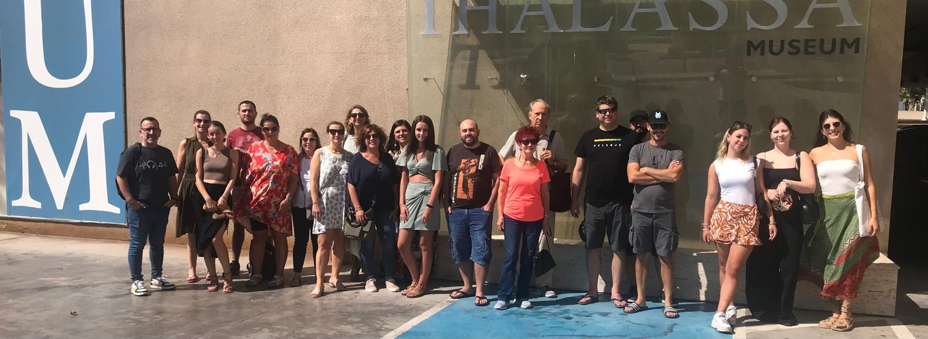
29.09.2024
On the final morning, the participants gathered for a farewell breakfast, providing one last opportunity to share moments together before parting ways. The breakfast was a relaxed and informal occasion, allowing everyone to reflect on the project’s journey and the friendships formed. Afterward, the partners prepared for their departures, bidding each other warm goodbyes with the promise of future collaboration. The departure marked the official end of the project, but the connections and experiences shared ensured that the impact of the partnership would continue beyond this final day.
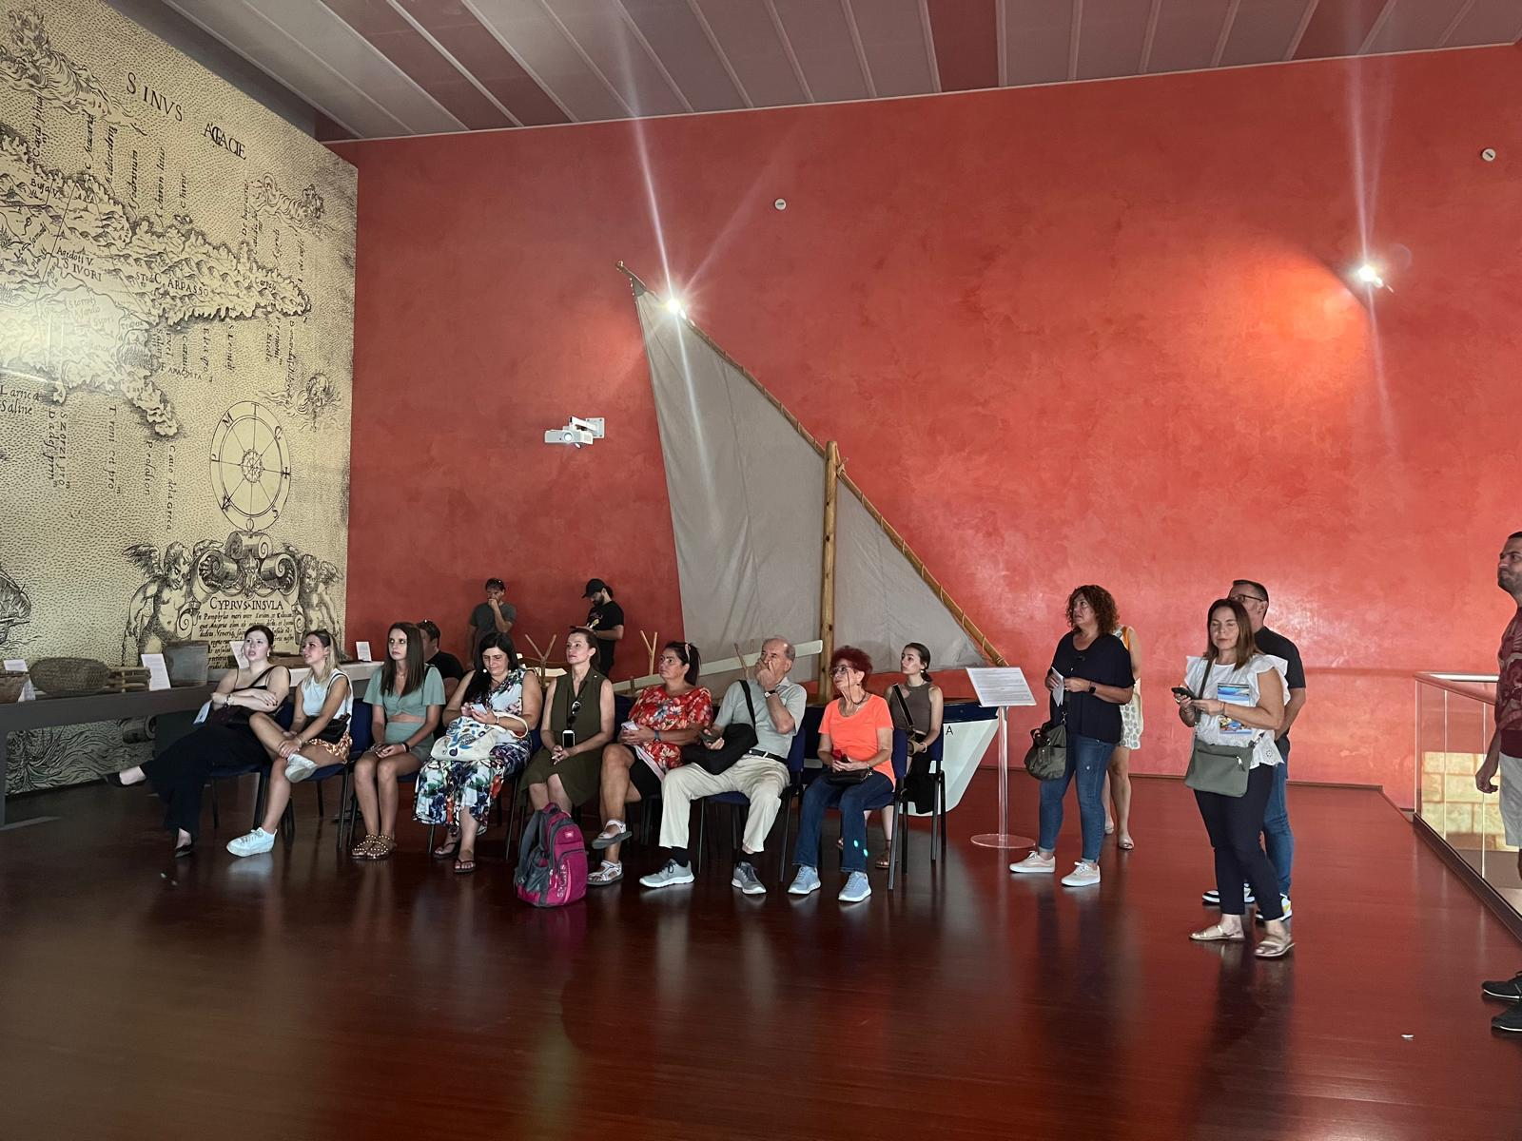

II) PROJECT COORDINATION
During the event in Cyprus, communication among participants was facilitated through a WhatsApp group. This platform allowed for the easy sharing of important information, such as locations for lunch and dinner, as well as photos and videos from the event. The WhatsApp group kept everyone informed and connected throughout the visit, ensuring smooth coordination. Additionally, before the event, CARDET held internal meetings to organize key logistical aspects, including accommodation, study visits, and other arrangements. Their efforts ensured that everything ran seamlessly, allowing participants to focus on the experience and the project’s goals.

HISTORY OF CHANGES
VERSION | PUBLICATION DATE | CHANGE
1.0 | 08.10.2024 | Initial version (new MFF).

