EVENT DESCRIPTION SHEET
(To be filled in and uploaded as deliverable in the Portal Grant Management System, at the due date foreseen in the system.
Please provide one sheet per event (one event = one workpackage = one lump sum).)
PROJECT
Project name and acronym: |  | YO-WO: Young Workforce â€“ Youth and Gender quality for Europe's Welfare
Participant: |  | CARDET CENTRE FOR THE ADVANCEMENT OF RESEARCH & DEVELOPMENT IN EDUCATIONAL TECHNOLOGY LIMITED, Cyprus
PIC number: |  | 886772934
EVENT DESCRIPTION
Event number: | 8
Event name | What opportunities does the EU offer?
Type: | - Dialogues with local experts on the topic "What Opportunities does the EU offer?" about Erasmus+ projects, the SVE, Youth Exchanges, among others.  - Debates with local students about European opportunities where youngsters will discover the importance of participating in EU policies.
In situ/online: | In situ - online
Location: | Slovenia
Date(s): | 19/04/2023 - 20/04/2023
Website(s) (if any): | https://tranquil-bienenstitch-592df3.netlify.app/project  https://www.lapoblallarga.es/va/pagina/projecte-yo-wo  https://www.lapoblallarga.es/va/noticia-pagina/projectes-europeus  www.bulgarian-youth.eu https://cardet.org/projects/yowo-young-workforce-youth-and-gender-equality-for-europe-s-welfare/ https://cardet.org/project-news/conclusion-of-yowo-project/  https://www.mc-velenje.si/evropski-projekt https://eidpfoundation.org/Projects/ https://www.ujszilvas.hu/ujszilvas/ https://autokreacja.org/blog/2024/11/14/yo-wo-young-workforce-youth-and-gender-equality-for-europes-welfare-summary/ https://ajmonnet.eu/es/yo-wo/
Participants
Female: | 20
Male: | 30
Non-binary: | 0
From country 1 [Slovenia]: | 35
From country 2 [Polska]: | 2
From country 3 [The Netherlands]: | 2
From country 4 [Spain] | 3
From country 5 [France] | 2
From country 6 [Cyprus] | 2
From country 7 [Hungary] | 2
From country [Bulgaria] | 2
Total number of participants: | 50 |  | From total number of countries: | 8
Description
Provide a short description of the event and its activities.

YOWO – SLOVENIA
Second meeting
Velenje, 19. – 20. 4. 2023
WP1: Initial meeting: NEETs and involvement in European policies.
PARTNER ORGANIZATIONS:
• Youth Center Velenje, Culture and Education (Slovenia)
• Municipality of La Pobla Llarga (Spain)
• Local Government of Town Újszilvás (Hungary)
• Fundacja Autokreacja (Poland)
• European Institute for Diplomacy and Policy (Netherlands)
• Jean Monnet (France)
• Bulgarian Youth Association (Bolgaria)
• CARDET (Cyprus)
OBJECTIVES:
- Enhance the knowledge about European programs, strategies and policies focused on the youth. - Young citizens development: further appreciation of the advantages of being part of the EU.
Description:
WP2: What opportunities does the EU offer?
Main activities:
-Dialogues with local experts on the topic "What Opportunities does the EU offer?" about Erasmus+ projects, the SVE, Youth Exchanges, among others.
- Debates with local students about European opportunities where youngsters will discover the importance of participating in EU policies.
- Every partner will explore how to implement these strategies in his own municipality lab. - Street Actions: "Local Europe" where participants will make interviews to local citizens about EU youth policie

I) DESCRIPTION OF THE ACTIVITIES TAKEN PLACE
19. 04. 2023
Participants arrived in Velenje, in the hotel Razgoršek, where we had a welcome dinner.
20. 04. 2023
On Wednesday we start a day in Youth center Velenje, where we prepared presentation of our programs, activies and EU projects (konS, European Solidarity Corps and Erasmus+ Youth Exchanges. EU for citizens). After that we visited our other infrastracture and met our employee in multimedia center Kunigunda, in new Pekarna in Old town, project konS office. We shared experiences and good practices on youth projects.
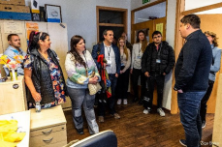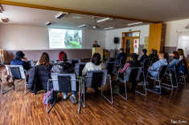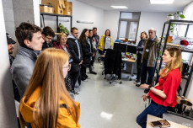
Then we visited Municipality Velenje, where we had dialogues with local experts. First our deputy mayor, Aleksandra Vasiljević, greet our delegates, then we met the leader of the Office for Economic Development and Restructuring, Helena knez, she prepared presentation about important EU projects and leader of the Office of Social Affairs, Marko Pritržnik, he prepered presentation of the city and his future challanges.
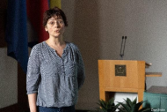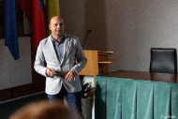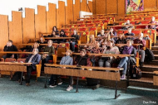

After that we went in Youth cultural club eMCe plac, unique product of close cooperation between the Youth Center Velenje and Student Club. The greatest added value of the club is to maintain principle: Youth for youth. Young people actively participate in program proposals in all areas, participate in the organization and implementation of events and activities, and have the opportunity to co-create a program that interests them and gain knowledge and experience in this field.
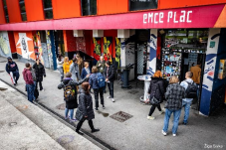
Next action was a Street Actions: "Local Europe" where delegates gathers in groups and went around the city to make short video interviews with local citizens about EU youth policies. They asked them various questions, for example: As a citizen of EU, what are the topics that worries you the most right now? What actions, politics or benefits should EU bring to the table to stay united? What are the beneficts for Youngsters?

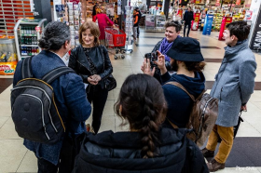

We ended first day with the dinner at little touristic farm Apat with good local food, we also invited two student, one, Yehor, from Ukraine and second, Uroš, from Serbia, to share the stories and their view of what EU can offer to youngsters.
21. 4. 2023
Second day we started with Workshop in Vila Bianca. It was moderated by journalist and longtime external colleague from Youth center Velenje, Tina Felicijan.
Partners were in groups and together exploring how to implement strategies, that we presented so far, in their own municipality lab.
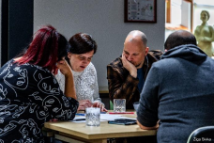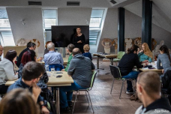
Then we went in Old town Velenje, where colleagues from the Municipality of Velenje, Vanesa and Domen, who are working on this project, presented Revitalization of the degraded urban part of the city that was financed by European Union. This is our good practice, that our town is really proud of. We took participants to family business Šili testenine, they are making delicious homemade pasta. Then we went to barber shop, creative center Čuk, in The Museum - House of Minerals, and our last stop was Pekarna, where we saw the edited movie about yesterdays Street actions.

We organized sightseeing tour of the city and lakes with an accredited tourist guide. We went to Vista, on the redevelopment area, which is located in a degraded urban area, which was created as a result of mining activity. The project was co-financed by the European Union from the European Fund for Regional Development.
We organized free entry at Castle Velenje for everybody.
After that we had a farewell dinner.

II) PROJECT COORDINATION
Coordinators had a short meetingon Wednesday and decided that we should all meet online after the Slovenian meeting to debate about our next one in Poland.
For communitaion during event in Slovenia we used WhatsApp group, where we share informations, locations for lunch and dinner, photos and videos.

HISTORY OF CHANGES
VERSION | PUBLICATION DATE | CHANGE
1.0 | 01.04.2022 | Initial version (new MFF).

