EVENT DESCRIPTION SHEET
(To be filled in and uploaded as deliverable in the Portal Grant Management System, at the due date foreseen in the system.
Please provide one sheet per event (one event = one workpackage = one lump sum).)
PROJECT
Project name and acronym: | Young Workforce – Youth and Gender Equality for Europe's Welfare
Participant: | AYUNTAMIENTO DE LA POBLA LLARGA
PIC number: | 886772934

EVENT DESCRIPTION
Event number: | 1
Event name: | Initial meeting: NEETs and involvement in European policies
Type: | Kick off Meeting
In situ/online: | In-situ
Location: | Spain, La Pobla Llarga.
date(s): | 28/02/2023 – 3/03/2023
Website(s) (if any): | https://www.lapoblallarga.es/va/pagina/projecte-yo-wo  https://www.lapoblallarga.es/va/noticia-pagina/projectes-europeus  www.bulgarian-youth.eu https://cardet.org/projects/yowo-young-workforce-youth-and-gender-equality-for-europe-s-welfare/ https://cardet.org/project-news/conclusion-of-yowo-project/  https://www.mc-velenje.si/evropski-projekt https://eidpfoundation.org/Projects/ https://www.ujszilvas.hu/ujszilvas/ https://autokreacja.org/blog/2024/11/14/yo-wo-young-workforce-youth-and-gender-equality-for-europes-welfare-summary/ https://ajmonnet.eu/es/yo-wo/
Participants
Female: | 33
Male: | 27
Non-binary: | 0
• Municipality of La Pobla Llarga (Spain) | 41
• Youth Center Velenje, Culture and Education (Slovenia) | 3
• Local Government of Town Újszilvás (Hungary) | 3
• Fundacja Autokreacja (Poland | 3
• European Institute for Diplomacy and Policy (Netherlands) | 1
• Jean Monnet (France) | 3
• Bulgarian Youth Association | 3
• CARDET (Cyprus). | 3
Total number of participants: | 60 | From total number of countries: | 8
Description
Provide a short description of the event and its activities.
activities
MINUTES
Kick off Meeting in la Pobla Llarga 28/02/2023 – 3/03/2023
KICK OFF MEETING IN LA POBLA LLARGA (SPAIN)

WP1: Initial meeting: NEETs and involvement in European policies.

PARTNER ORGANISATIONS ATTENDING THE MEETING:
- Municipality of La Pobla Llarga (Spain)
- Youth Center Velenje, Culture and Education (Slovenia)
- Local Government of Town Újszilvás (Hungary)
- Fundacja Autokreacja (Poland)
- European Institute for Diplomacy and Policy (Netherlands)
- Jean Monnet (France)
- Bulgarian Youth Association
- CARDET (Cyprus).

OBJECTIVES:

- Enhance of the understanding of the project's results, work procedures and results to achieve.
- Strengthen the abilities about youth participation in EU policies and NEET phenomena.
- Local citizens participation by way of interactive action and the gathering of the first information about communication tolos

I) DESCRIPTION OF THE ACTIVITIES TAKEN PLACE
28/02/2023
Arrival of Participants from each partner delegation.
Wellcome from City Councelors, teambuilding activities and welcoming dinner in Xativa.

1/03/2023
The participants came to the Casa de la Joventut de la Pobla Llarga. First of all the mayoress of the town, Neus Garrigues, officially welcomed the participants of the kick-off meeting in the framework of the European project YO-WO. After her, Mr. Andreu Garrido, presented the project and welcomed all participants, he also presented the project and the objectives to be achieved with the implementation of the project, both at provincial and international level. Youth and Gender Equality for the Welfare of Europe is a fundamental mission for the city of La Pobla Llarga and all its departments, it is the future for which we must fight.
Afterwards, a presentation was made by all the partners of the programme about their organisation, municipality, general and specific objectives that they intend to achieve in this project.
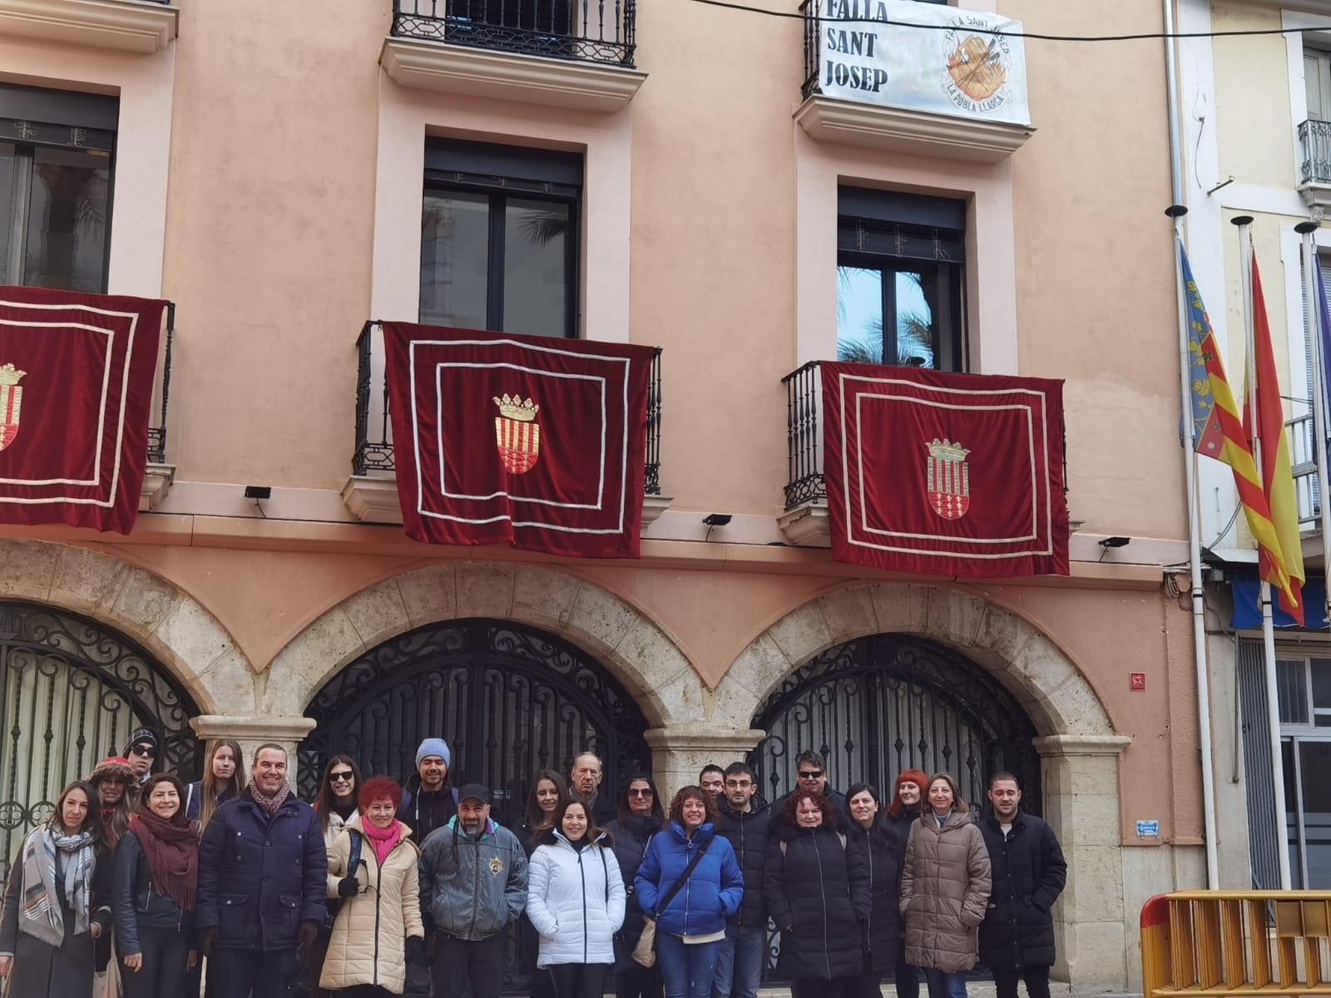

Then, several presentations were made within the theme of the project.
Firstly, the Empoblar project was presented by Inma from Pobla Llarga, which is a project to promote and support youth entrepreneurship subsidised by the Pobla Llarga town council. It is a perfect example of good practices where the participants could see what kind of youth policies are developed in the municipality. In addition to supporting local citizen participation through interactive action and the collection of the first information on all media.

Secondly, there was a presentation on EU history, Jean Monnet, Youth and European Values carried out by Miguel Ángel Martín Ramos, Vice-president of the Jean Monnet Association, in collaboration with the European and Ibero-American Academy of Yuste Foundatin, a very important association at European level, which is part of this project, and with headquarters in the House of Jean Monnet in Bazoches-sur-Guyonne, France. 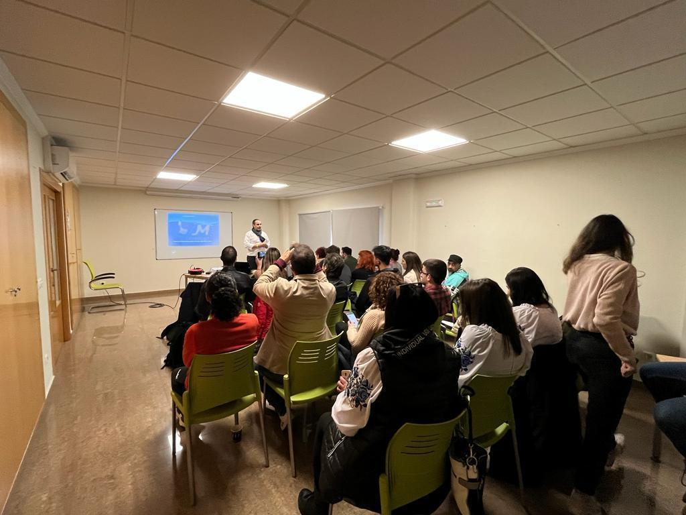
Thirdly, we visited an example of good practice in the town, visiting the artisan chocolate shop Mario Padial, a benchmark in the world of confectionery and a perfect example that from a town like La Pobla Llarga you can also develop a business idea at international level.
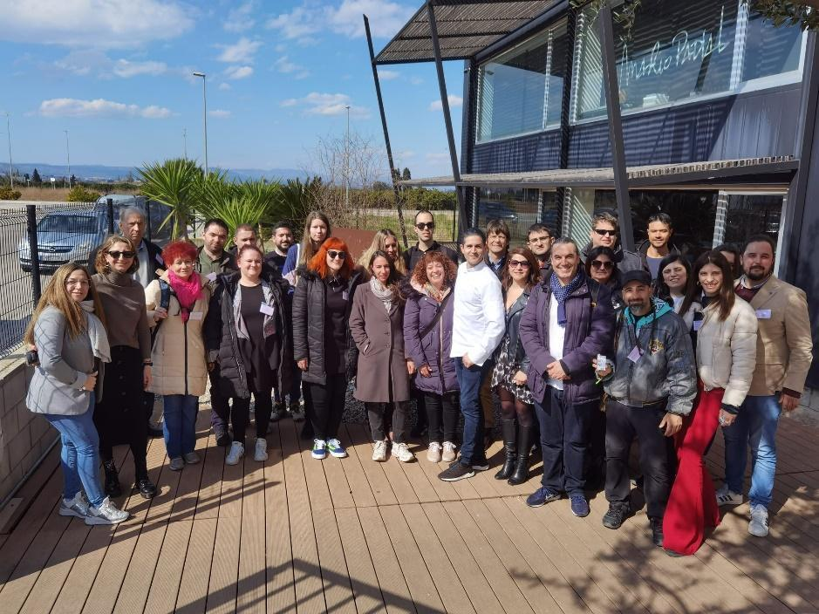

Fourthly, in the afternoon, a visit was made to a very important industrial orange juice and orange production company in the area, which works both exporting and importing this product at national and international level.
This is a very important company for the economy of the municipality, which has 500 workers in the plant and a high production during the year. It was a unique opportunity to visit the plant and all its levels.
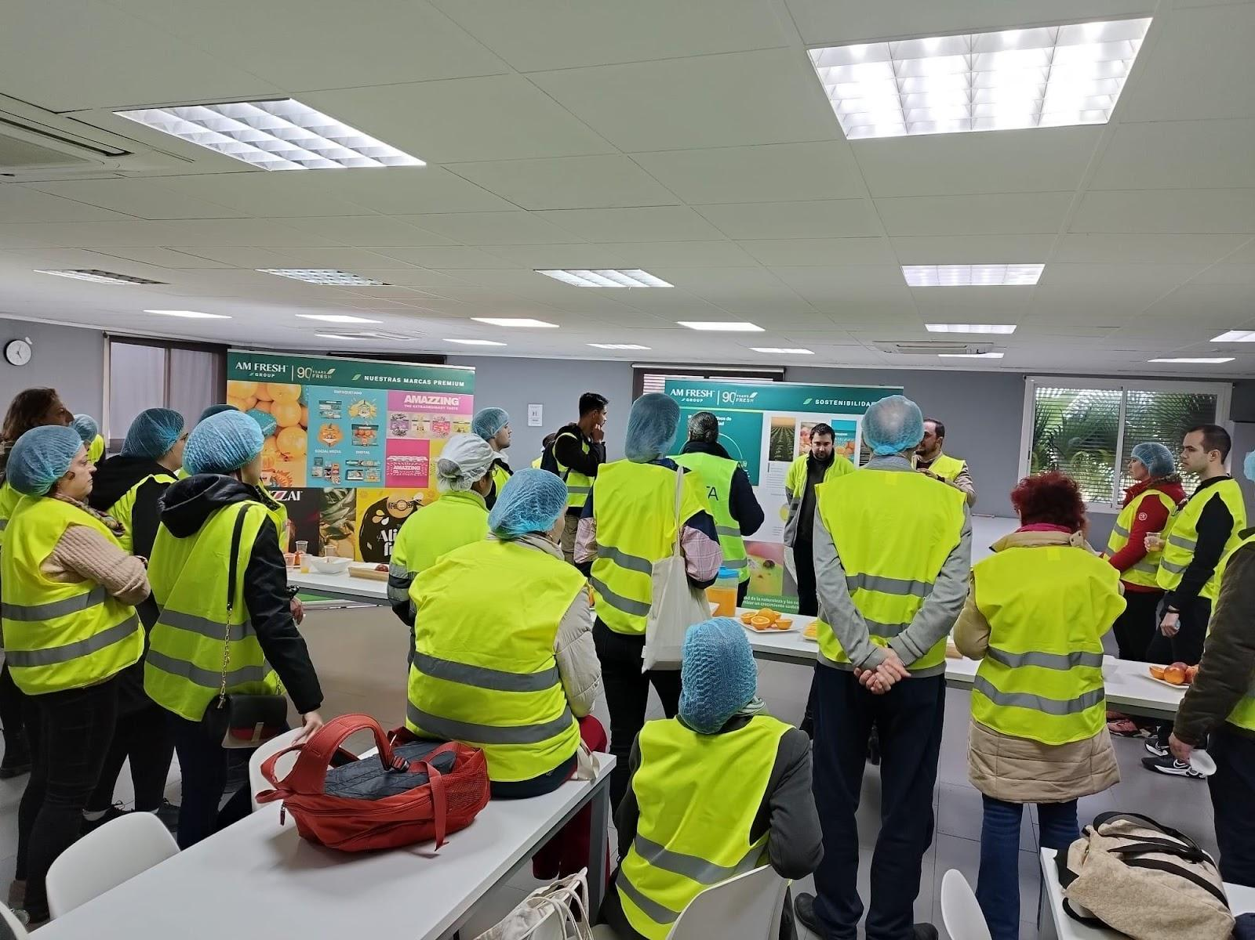
Later there was a tour of the town to explain and learn about the history of La Pobla Llarga and the day ended with a cultural concert by the local municipal band and ended the day with a multicultural dinner.
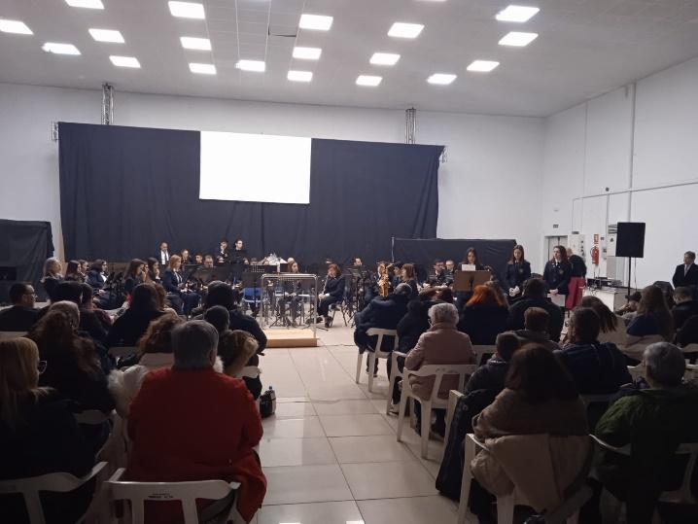

2/03/2023
The second day of activity started with a Municipality Lab presented by Carla Serena, presenting a project on entrepreneurship and care for women in the municipality of La Pobla Llarga. This project aims to create a network of psychological and social support for women in the area in support of gender violence and equality.
Afterwards the team moved to the city of Valencia to see the Fallas festival, the great economic impulse of the Valencian Community, and in this way get an idea of how the economy of the area can be boosted.

II) PROJECT COORDINATION
The coordination session took place, where the main characteristics of the YO-WO project, the different products that will be developed in the different periods of the project, the work packages, the project model, the project objectives, the work packages, the funding model and the communication plan were explained.
Partners debated about the project calendar of Wps, and they confirmed the following dates:
- WP1 Municipality of La Pobla Llarga (Spain) – 28/02/2023 until 3/03/2023
- WP2 Youth Center Velenje, Culture and Education (Slovenia) – 18/04/2023 until 21/04/2023
- WP3 Local Government of Town Újszilvás (Hungary) – 11/09/2023 until 14/09/2023
- WP4 Fundacja Autokreacja (Poland)
- WP5 Hellenic Institute of Cultural Diplomacy Netherlands(Netherlands)
- WP6 Jean Monnet (France)
- WP7 Bulgarian Youth Association
- WP8 CARDET (Cyprus).
The calendar had some changes in relation to the grant agreement after discussion between the partners about their availability to organise their international events (WP). All these dates were agreed by the participants of the meeting.
The partners discussed about the doubts in the internal cooperation agreement signed by all partners with the Lead Partner. All partners brought original copies of the document and signed by the Mayor of la Pobla Llarga. After this, the municipality of la Pobla Llarga will proceed with the first payment of the pre-financing of the project. Other issues that were discussed were: number of participants per meeting, responsibilities among partners, etc.
All partners agreed on their tasks at local level, involving local volunteers and creating a working group of volunteers who will participate in the implementation of the project at local level. All partners should work on it and report on their progress during the next event.

III) COMMUNICATION PLAN
- Internal Communication
  - I It was agreed among all partner organisations that informal communications will be foreseen through the WhatsApp group to share potos/videos or exchange words in an informal way among the rest of the partners.
  - It was agreed among all partner organisations that formal communications will be done through email exchanges, where partners will be informed about the following events, products or deliverables, material sent by partners (Agenda, Infopack) and any other kind of information relevant to the YO-WO proposal. For this purpose, the YO-WO project will have a contact list that will be updated by each project partner.
  - The partners agreed that a google drive folder will be created to share relevant information of the project.
  - The local school created 7 logos for the project, which were then presented to the partners and chose the following logo to represent the project.
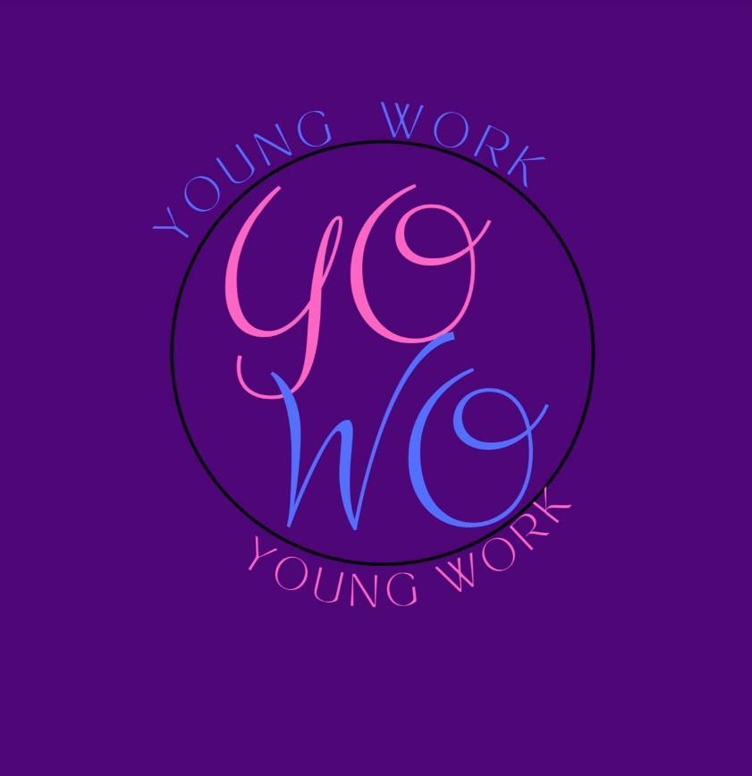

HISTORY OF CHANGES
VERSION | PUBLICATION DATE | CHANGE
1.0 | 01.04.2022 | Initial version (new MFF).

